TOUSE: A Fair User Selection Mechanism Based on Dynamic Time Warping for MU-MIMO Networks

Zhaoshu Tang, Zhenquan Qin, Ming Zhu
Jian Fang, Lei Wang, Honglian Ma
Key Laboratory for Ubiquitous Network and Service Software of Liaoning Province
School of Software, Dalian University of Technology
Dalian, Liaoning – P. R. China
[e-mail: zhuming@dlut.edu.cn]
*Corresponding author: Ming Zhu

Received October 5, 201X; revised November 10, 201X; accepted November 20, 201X;
published December 25, 201X

Abstract

Multi-user Multiple-Input and Multiple-Output (MU-MIMO) has potential for prominently enhancing the capacity of wireless network by simultaneously transmitting to multiple users. User selection is an unavoidable problem which bottlenecks the gain of MU-MIMO to a great extent. Major state-of-the-art works are focusing on improving network throughput by using Channel State Information (CSI), however, the overhead of CSI feedback becomes unacceptable when the number of users is large. Some work does well in balancing tradeoff between complexity and achievable throughput but is lack of consideration of fairness. Current works universally ignore the rational utilizing of time resources, which may lead the improvements of network throughput to a standstill. In this paper, we propose TOUSE, a scalable and fair user selection scheme for MU-MIMO. The core design is dynamic-time- warping-based user selection mechanism for downlink MU-MIMO, which could make full use of concurrent transmitting time. TOUSE also presents a novel data-rate estimation method without any CSI feedback, providing supports for user selections. Simulation result shows that TOUSE significantly outperforms traditional contention-based user selection schemes in both throughput and fairness in an indoor condition.

Keywords: MU-MIMO, user selection, fairness, dynamic time warping
1. Introduction
Multi-user Multiple Input Multiple Output (MU-MIMO) has already attracted a huge amount of attention because of the ability of better spatial reuse. The network capacity is dramatically enhanced by sending frames to multiple single-stream users concurrently. Prior to 802.11ac, traditional 802.11 protocol limits up to one user per transmission sent, which cannot fully utilize spatial resources supported by multiple antennas access point (AP). To solve this disadvantage, here comes the Multi-user transmission, a new technology within 802.11ac. By using MU-MIMO [1], AP is equipped with multiple antennas, and adaptable to transmissions among multiple users at one time. In possession with these abilities, MU-MIMO has the potential to change the way in which Wi-Fi networks are built and achieves improved capacity gains. Now, since 802.11ac has already been standardized, IEEE 802.11ac systems has been becoming widely deployed in real world.
Theoretically, the capacity of MU-MIMO downlink system gains increases linearly with the number of transmitting and receiving antennas. But in practice, the number of antennas is limited by several reasons, and the inter-user interference could not be ignored. These lead to a series of key problems. First, how an AP selects a beamforming group of users and transmits simultaneously. Second, how to determine the size of the beamforming group. Different beamforming group selection leads to various transmitting rates, then influences the overall network performances. Unwise selecting method may result in a huge waste of space-time at any single transmitted slot, in addition to the cause of the fairness and complexities. To make a better optimal selection, we should choose a metric like sum rate as a criterion to process the feedback information like Channel State Information (CSI) or Signal Noise Ratio (SNR), design an efficient scheduling scheme based on various data we obtained.
Substantial researches [2] have provided the solving methods to the user selection problem for MU-MIMO. Most solutions select the optimal beamforming group based on the full CSI feedback by all potential users, like semi-orthogonal user selection algorithm (SUS) [3] and minimum of the frobenius norm of the pseudo-inverse algorithm (MFNPI) [4]. CSI reflects the characteristics on the channel including fading distributions, average channel gains and spatial correlations, which all are the key factors for beamfroming group select. However, CSI is calculated by estimating the training sequence from AP, then users feed it back to the AP. Because of the long and compliacted process, reducing the CSI overhead seems to be a significance [5]. Although numerous optimization schemes of feedback have been proposed, like compression algorithms [6], the overhead of CSI feedback is still huge sometimes and severely affects the performance of network, since the overhead grows linearly with the number of users. Even worse, infrequent CSI feedback results in outdated, which may leads to the inter-user interference. It is convenient to select beamforming group within CSI, but intolerable for MU-MIMO system with unacceptable feedback overhead.
In fact, these challenges have motivated previous works to find better possible solutions for user selection. In [5], the author proposed a distributed contention mechanism that singles out the best user to feed back its CSI. Narendra [7] presented the pre-sounding user selection algorithm only using available pre-sounding information instead of posting channel sounding information, and solved the problem of feedback overhead to a certain extent. Other than theoretical contributions to MU-MIMO, Xiaofu [8] implements efficient algorithms in the practical 802.11ac systems with measurements considering both the throughput and user air time fairness.
In this paper, we propose Time Optimal User Selection based on Effective SNR (TOUSE), a scalable and fair user selection scheme for MU-MIMO networks to achieve higher throughput. To sum up, our main contributions are as follows:
- We implement a low complexity feedback mechanism to obtain the available channel information and present a novel data-rate estimation method based on the information of effective SNR [9] without CSI feedback.
- We design double constraint for user selection in order to maximize network throughput, and propose a novel dynamic-time-warping-based user selection algorithm to select beamforming group in a fair way.
- TOUSE has abilities to adapt to different network channel qualities, no matter what the quality of channel. It is also suitable for dynamic network, since it selects users after channel sounding is completed and acquires real-time information (effective SNR feedback).
- Finally we experimentally evaluate the performance of TOUSE. Result shows that, on average, the throughput gain of TOUSE is 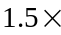 over traditional random user selection scheme in 3-antennas AP scenarios and fairness performance is similar. Compared with PUMA scheme [7], TOUSE have similar performance in network throughput but better performance in user air time fairness.
The rest of this paper is organized as follows. In Section 2 we present background of user selection in MU-MIMO. Section 3 provides an overview of the components of TOUSE. Section 4 evaluates the performance of TOUSE with experimentations. Then we describe related works in Section 5 and Section 6 concludes the paper.
2. Related Work
Wireless standards like 802.11ac [10], LTE [11] have recently pushed toward the use of MU-MIMO for obtaining high-speed and high-throughput wireless communication. The work [12] presented a study to random access based on MAC mechanisms for MU-MIMO, and gives a survey and categorizes to the most relevant MU-MIMO MAC proposals. It also identified key requirements for designing efficient MU-MIMO MAC protocols including de/pre-coding [1] and scheduling schemes. The potential of MU-MIMO has been investigated both theoretically [13] and empirically [14], which studied pre-coding techniques, scheduling schemes and practical gain of MU-MIMO in various environments.
Substantial theoretical works [15] assumed that CSI is available and paid much attention on implementing low-complexity algorithms to approach the maximum throughput. Xie et al., [5] presented scalable and adaptive user selection which requires several rounds of CSI feedback instead of gathering from all users. However, in reality, the vulnerabilities of CSI [16] still exist due to its estimation methods, like time overhead. To avoid overwhelming the actual channel time spent on transmission, the schemes of user selection without CSI feedback was proposed. The authors of [17] design an orthogonality evaluation mechanism which enables each user using its own CSI to speculate. But it can only be applied to uplink MU-MIMO. In [7], it proposed a method of user selection prior to channel sounding and exploits theoretical properties of MU-MIMO system to estimate datarate. PUMA achieves better performance in throughput, however, it does not do well in the respect of fairness. In [18], it proposes an efficient method for combing multi-user MIMO (MU-MIMO) employing Tomlinson Harashima precoding with semiorthogonal user selection (SUS).
Some other works focus on the scheduling scheme of user selection [19]. Mostly [20] either iteratively select a user that minimizes the interference, reduces the complexity or maximizes the aggregate throughput. In [21], a novel search and updated strategy was proposed for user selection. It designed a knob to control tradeoff between aggregate capacity and computational complexity. The work [22] presents a low complexity scheduling scheme using block diagonalization with chordal distance.
In addition, some experimental studies emerged, like [23]. Authors realizes netMIMO downlink transmission for large-scale wireless network. By organizing a network into clusters, it could manage interference with a decentralized channel-access algorithm, but environment is limited in static network since time-averaged CSI is used as input. In [24], Shen et al., introduced TurboRate, client annotates its packets with single SNR and direction at the AP to obtain the optimal bit rate and could transmit concurrently. Now there are more conditions are considered, like mobility [25] or channel control [26]. The exciting thing is that the team of Xinyu Zhang [27] has optimized MU-MIMO performance in 802.11ac commodity devices. In [8], it develop an efficient graph matching algorithm based on graph theory principles and evaluate in terms of 802.11ac systems.
So far, there are three key points in MU-MIMO MAC protocol design: throughput, complexity and fairness [28]. But most researches only consider two or one of these points. TOUSE is designed a novel metric without CSI feedback benefiting from [29], and presents a fair user selection mechanism based on overhead time matches.
3. Background and Challenges
3.1 MU-MIMO System Model
In a downlink MU-MIMO system, consider a single-cell MIMO with a single base station serving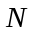users. The base station is equipped withantennas and the client with one or more receive antennas. We assume that AP sends frames to a set of selected single antenna users called beamforming group at the same time, which satisfies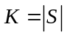, 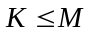. Due to the bad effect of multi-user interference at the client side, it is essential for AP to precode outgoing signals to minimize the bad effect of interference among simultaneous streams. Owing to its low complexity, AP applies Zero-forcing beamforming(ZFBF) [5]. In ZFBF, user streams are separated by different beamforming directions. Let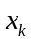denotes the data symbol sending to user,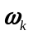be the beamforming weight vector, and present the transmit power. Assume is the channel state vector between transmission antennas and receiver . Define , , the transmitted signal . Then, let denotes the noise level of user , and the received signal vector is:

(1)

To eliminate the interference from other beamforming frame streams, ZFBF should satisfy the zero-interference condition: for all receivers , . So that receiver only gets its symbol . Let the channel state matrix and the beamforming weight matrix . One optimal choice of W that satisfies zero-interference condition is the pseudo-inverse of H:
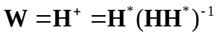. (2)
SOM is trained iteratively. In each training step, one sample vector x from the input data pool is chosen randomly, and the distances between it and all the SOM codebook vectors are calculated using some distance measure. The neuron whose codebook vector is closest to the input vector is called the best-matching unit (BMU), denoted by 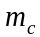:

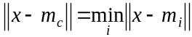 (1)

where 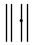 is the Euclidean distance, and 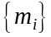 are the codebook vectors.
After finding BMU, the SOM codebook vectors are updated, such that the BMU is moved closer to the input vector. The topological neighbors of BMU are also treated this way. This procedure moves BMU and its topological neighbors towards the sample vectors. The update rule for the ith codebook vector is:

(2)

where n is the training iteration number, x(t) is an input vector randomly selected from the input data set at the nth training, 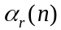 is the learning rate in the nth training, and 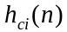 is the kernel function around BMU . The kernel function defines the region of influence that x has on the map.
…
Fig. 1 shows the U-matrix and the components planes for the feature variables. The U-matrix is a visualization of distance between neurons, where distance is color coded according to the spectrum shown next to the map. Blue areas represent codebook vectors close to each other in input space, i.e., clusters.
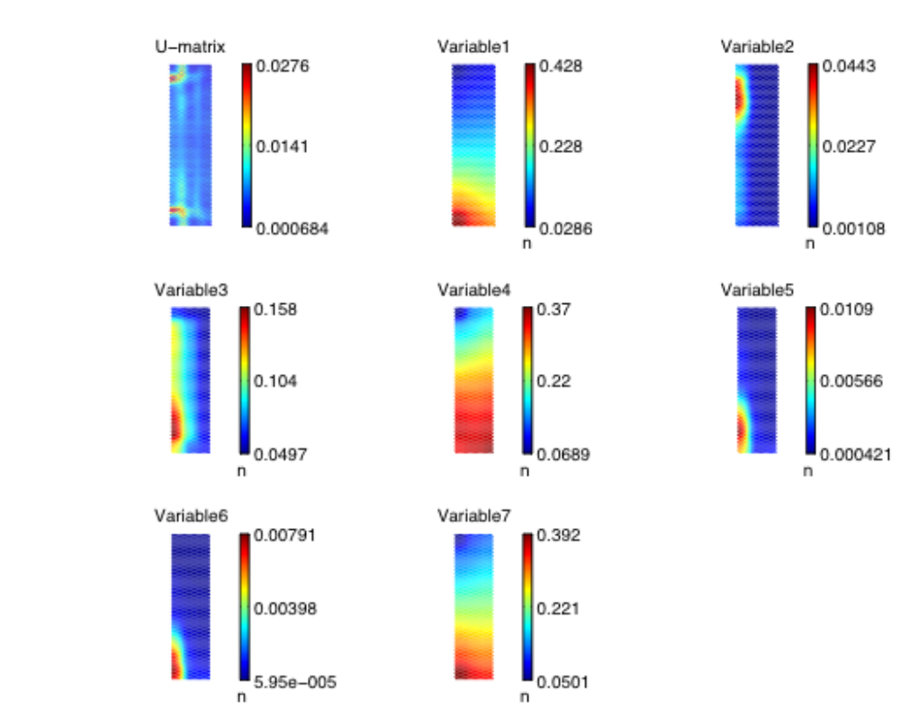
Fig. 1. U-matrix with 7 components scaled to [0,1]

...
3.2 K-Means Clustering
The K-means clustering algorithm starts with a training data set and a given number of clusters K. The samples in the training data set are assigned to a cluster based on a similarity measurement. Euclidean distance is generally used to measure the similarity. The K-means algorithm tries to find an optimal solution by minimizing the square error:

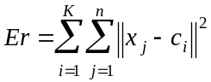 (3)

where K is the number of clusters and n is the number of training samples, is the center of the ith cluster, 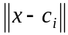 is the Euclidean distance between sample x and center of the ith cluster.
…
4. Experimental Classification Results and Analysis
The previous section identified three clusters for QoS classes and features to build up classification rules through unsupervised learning. In this section, the accuracy of the classification rules is evaluated experimentally. For classification, we chose the K-nearest neighbor (KNN) algorithm. Experimental results are compared with the minimum mean distance (MMD) classifier.
…

The selected application lists for each class and the number of applications in each class are shown in Table 1.

Table 1. Applications in each class
Class | Applications | Total number
Transactional | 53/TCP, 13/TCP, 111/TCP,… | 112
Interactive | 23/TCP, 21/TCP, 43/TCP, 513/TCP, 514/TCP, 540/TCP, 251/TCP, 1017/TCP, 1019/TCP, 1020/TCP, 1022/TCP,… | 77
Bulk data | 80/TCP, 20/TCP, 25/TCP, 70/TCP, 79/TCP, 81/TCP, 82/TCP, 83/TCP, 84/TCP, 119/TCP, 210/TCP, 8080/TCP,… | 1351
5. Conclusion
Traffic classification was carried out in two phases. In the first off-line phase, we started with no assumptions about traffic classes and used the unsupervised SOM and K-means clustering algorithms to find the structure in the traffic data. The data exploration procedure found three clusters corresponding to three QoS classes: transactional, interactive, and bulk data transfer. …
In the second classification phase, the accuracy of the KNN classifier was evaluated for test data. Leave-one-out cross-validation tests showed that this algorithm had a low error rate. The KNN classifier was found to have an error rate of about 2 percent for the test data, compared to an error rate of 7 percent for a MMD classifier. KNN is one of the simplest classification algorithms, but not necessarily the most accurate. Other supervised algorithms, such as back propagation (BP) and SVM, also have attractive features and should be compared in future work.
References
- Thuy Nguyen and Grenville Armitage, “A survey of techniques for Internet traffic classification using machine learning,” IEEE Communications Surveys and Tutorials, vol. 10, no. 4, pp. 56-76, November, 2008.
- H. Trussell, A. Nilsson, P. Patel and Y. Wang, “Estimation and detection of network traffic,” in Proc. of 11th Digital Signal Processing Workshop, pp. 246-248, January 12-16, 2004.
- Anthony McGregor, Mark Hall, Perry Lorier and James Brunskill, “Flow clustering using machine learning techniques,” in Proc. of 5th Int. Workshop on Passive and Active Network Measurement, pp.205-214, June 2-7, 2004.
- Sebastian Zander, Thuy Nguyen and Grenville Armitage, “Self-learning IP traffic classification based on statistical flow characteristics,” in Proc. of 6th Int. Workshop on Passive and Active Measurement, pp.325-328, March 23-27, 2005.
- Sebastian Zander, Thuy Nguyen and Grenville Armitage, “Automated traffic classification and application identification using machine learning,” in Proc. of IEEE Conf. on Local Computer Networks, pp.250-257, February 11-12, 2005.
[6] T. M. Cover and J. A. Thomas, Elements of Information Theory, 2nd Edition, Wiley, New York,
2009.

■ Important Requirements for Accepted Papers only
This is an important requirement for all of the accepted papers. Thus once your manuscript is finally accepted for publication in our journal, the authors should do the following requirement.

All the references in the manuscript should have its DOI link. Please follow the step-by-step procedures
to put the DOI link:

1) Register your e-mail ID in http://www.crossref.org/requestaccount/
2) Enter your registered e-mail ID and all the references in the boxes in http://www.crossref.org/SimpleTextQuery/

ex) Let’s enter the following two references together and then press “Submit” button. You will receive two DOIs in blue color below for them, respectively.

F. Hou, L. X. Cai, J. She, P. Ho, X. Shen and J. Zhang, “Cooperative multicast scheduling scheme for IPTV over IEEE 802.16 Networks,” IEEE Transactions on Wireless Communications, vol. 8, no. 3, pp. 1508-1519, Mar. 2009.
doi:10.1109/TWC.2009.080417
Thuy Nguyen and Grenville Armitage, “A survey of techniques for Internet traffic classification using machine learning,” IEEE Communications Surveys and Tutorials, vol. 10, no. 4, pp. 56-76, November, 2008.
doi:10.1109/SURV.2008.080406

Important: If any reference does not have its own DOI, no DOI will be returned. For that case, you don’t need to put a DOI for the reference. But almost all of journal papers have their DOI. Thus if the CrossRef’s automatic DOI searcher fails to find a DOI, you SHOULD google with the title of the journal paper. For instance, the DOIs of the following journal papers couldn’t be found by the CrossRef automatic DOI searcher but we could find the DOIs by googling with the title of the journal paper:

[1] Zabin. F, Misra. S, Woungang and I, Rashvand. H,F. Ma, N.-W, Ahsan Ali, M, “REEP:
data-centric, energy-efficient and reliable routing protocol for wireless sensor networks,” IET
Communications, vol. 2 , no 8, pp. 995-1008, 2008.
http://ieeexplore.ieee.org/Xplore/login.jsp?url=http%3A%2F%2Fieeexplore.ieee.org%2Fiel5%2F4105970%2F4607188%2F04607189.pdf%3Farnumber%3D4607189&authDecision=-203

[2] O. Powell, P. Leone and J. Rolim, “Energy Optimal Data Propagation in Wireless Sensor Networks,” J. Parallel and Distributed Computing, vol. 67, no. 3, pp. 02-317, 2007.
http://portal.acm.org/citation.cfm?id=1224643

3) Now you just add the DOIs link to the references in your paper. When you add the DOI in the
reference, you should attach a prfix, http://dx.doi.org/ to the front of each DOI.

ex) For the two examples,

F. Hou, L. X. Cai, J. She, P. Ho, X. Shen and J. Zhang, “Cooperative multicast
scheduling scheme for IPTV over IEEE 802.16 Networks,” IEEE Transactions on
Wireless Communications, vol. 8, no. 3, pp. 1508-1519, Mar. 2009.
http://dx.doi.org/doi:10.1109/TWC.2009.080417
Thuy Nguyen and Grenville Armitage, “A survey of techniques for Internet traffic
classification using machine learning,” IEEE Communications Surveys and Tutorials, vol. 10, no. 4, pp. 56-76, November, 2008.
http://dx.doi.org/doi:10.1109/SURV.2008.080406

4) Last, you should put a DOI link tag name, “Article (CrossRef Link)” as following:
You just place the cursor on the DOI link and click the right button of your mouse and then select the “Hyperlink Edit” menu. Enter the tag name “Article (CrossRef Link)” in the text box.

[1] F. Hou, L. X. Cai, J. She, P. Ho, X. Shen and J. Zhang, “Cooperative multicast scheduling scheme for IPTV over IEEE 802.16 Networks,” IEEE Transactions on Wireless Communications, vol. 8, no. 3, pp. 1508-1519, Mar. 2009. Article (CrossRef Link).

[2] Thuy Nguyen and Grenville Armitage, “A survey of techniques for Internet traffic classification using machine learning,” IEEE Communications Surveys and Tutorials, vol. 10, no. 4, pp. 56-76, November, 2008. Article (CrossRef Link).

-END-

